Rhetoric Kingdom
prebeared by:
- سناء محمد عبدالوهاب
- سلسبيل سيد كمال
- سهيله حمدى عبدالعال
- سلمى محمد سعد
- شروق احمد عبدالباسط

group: one.
- Project Charter Elements:
Official Project Name: Rhetoric Kingdom.
- Project Sponsor :
- Ministry of Culture.
- Ministry of Education.
- Project Manager: saad Eldeen.

- Purpose Of The Project :
- Save time, effort and money.
- The customer can easily find the model library.
- Provide the possibility of visual or audio reading.

- Business Case For The Project :
- Kingdom of Rhetoric application allows users to compare libraries in just a few clicks.
- We help millions of readers to get to the books they want in the least time and effort by providing information on all the libraries in which the book is available and comparing them and bringing out the closest model library to the reader.
- The application provides the user with the ability to read online whether visual or audio reading.
6. Key deliverables of the project:
- Website
- Application
- EBooks offline
- International and local books
- Buy and borrow books

7. General statement about how the team will approach the work:
- Identifying the main idea
- Identify funders
- Identify the rest of the sub-targets
- Setting the deadline
- Making propaganda
- Distribution of tasks to team members
- beginning of implementation

8. Basic timeline of when the project milestones will be reached.
- Building the electronic library takes 18 week.
- Creating a platform to search for the book and gather information about it takes 6 weeks.
- Creating an online platform to publish books for coworkers takes 6 weeks.
- Providing the books of the authors in offices and exhibitions, and providing information about them in the offices 6 weeks.

- Project resources, budget, staff, and vendors.
- Budget :
- The cost of publishing an electronic periodical is lower than its traditional counterpart, due to the electronic capabilities
- And its ability to overcome the problems of issuing periodicals, especially the difficulties of publishing and circulation of the periodical in stages Prepare it first.
- The cost of printing and marketing is no longer based on prices Paper and sales volume as they were in the pre-network era
- It is possible that the decline in the cost of computers and communication networks has a role in reducing the cost of publishing periodicals.
- Electronic journals and make it less than the cost of publishing paper periodicals,
- Also, according to studies, the cost of the electronic periodical is less than the cost the paper periodical by between 70% and 90%.
- Resources
- The world digital library
- Project Gutenberg

- Summary budget.
- 57000
- High level assumptions and constraints.
- Copyright claim.
- Digital preservation.

- High-level risks.
- The cost is high in general because Electronic publishing requires the availability of entrances to techniques that are considered relatively advanced in many societies.
- Solution : Establish weekly, monthly and yearly offers to subscribe to the application

- Electronic publications can only reach a very limited number of potential beneficiaries.
- Solution: Good e-marketing for the application through social media, educational sites and television advertisements

- The techniques used in electronic publishing are still characterized by some complexity and not easy to use for someone who has no knowledge of the subject.
- Solution: Create simplified videos for the user on how to use the application when starting to use the application.

- Some computers have an additional problem other than retrieval of electronically published publications, which is a problem Displaying information as the small size of the screen on some computers does not allow the reader to see a part of it enough information at the same time.
- Solution: Allowing the ability to control the screen size (font size and image size) to suit all versions of devices

- Information technology consumes a lot of effort from the beneficiaries compared to what is needed to use a paper book In the case of electronic publishing, the effort required to enter the network, access the publication, read it and copy it sometimes It is much larger than traditional publishing requires.

- Solution: Availability of the application offline to facilitate the user to access it in the absence of a network.
  - The project scope statement :

- Product Scope Description:
- The goal of this project is to provide all facilities to the readers.
- Creating an electronic library that provides its readers with all pdf books and novels.
- It also makes these same audio books available to those who are unable to read, such as blind people, children and illiterate people.
- If the researcher wants these books on paper, we save him the time and effort of research.
- By providing him with all the information he wants from the location of the nearest library to him and the types and names of books available in them, and if he wants them used at the lowest price.
- This project will also allow receiving and discovering new writers by providing them with opportunities and competitions.
- Presenting their first writings to us to encourage them.
- The main objective of this project is to facilitate reading and spread culture among all age groups by facilitating access to it.
- Product Acceptance Criteria:
The application will provide all kinds of books, articles, novels and stories. It will also provide these same audio books for people who cannot read, such as children and the blind. Easy access to books with minimal effort, Also ,easyaccess to rare books. Thus, you will not have to go to the library as long as you have the Internet .It is accessible 24 hours a day.
- Project Deliverables:
- Website
- Application
- EBooks offline
- International and local books
- Buy and borrow books
.
4) Project Exclusions:
The application cannot be accessed without the Internet. It should be all kinds of book pdf. The application does not accept cash payments, electronic payment must be made when purchasing any book.
5) Project Constraints:
The application will provide all facilities for the readers. The cost of the project is 57000 $. The time it takes to plan the project is a month. The time it takes to implement the project is a month. The application will take about 3months until users can use it. There should be all kinds of books, novels and stories pdf.
6) Project Assumptions:
This application will be global in the world and will be used by a very large number of users. It will provide all books, whether read or audio. This application will be the most effective.

- The WBS :

- The code of the project _A_.
- Design of the mobile app part_A.1_.
- Design the interface of the app_A.1.1_.
- Design the interface of searching and borrowing books_A.1.1.1_.
- Design the interface of reading and listening to books_A.1.1.2_.
- Design the interface of author books_A.1.1.3_.
- Coding _A.1.2_.
- Design of the website part_A.2_.
- Front end _A.2.1_.
- Design the main site interface_A.2.1.1_.
- Design the platform of searching and borrowing books_A.2.1.1.1_.
- Design the interface of reading and listening to books_A.2.1.1.2_.
- Design the interface of author books_A.2.1.1.3_.
- Coding _A.2.1.2_.
- Back end _A.2.2_.
- Design the dashboard to control the searching and borrowing books part_A.2.2.1_.
- Design the dashboard to control the reading and listening to books part_A.2.2.2_.
- Design the dashboard to control the author books part _A.2.2.3_.
- Coding _A.2.2.2_.
- Data base _A.3_.
- Table design_A.3.1_.
- Design the relations between tables_A.3.2_.
- Data entry_A.3.3_.
- Testing _A.4_.
- Test the data base _A.4.1_.
- Test the back end _A.4.2_.
- Push_A.5_.
- Media_A.6_.

- Dictionary

- 101.1 Design of the mobile app part.
- The code of The Project 101.
- 101.1.1 Design the interface of the app.
- 101.1.1.1 Design the interface of searching and borrowing books.
- Code: 101.1.1.1
- Description: The user searches for the book, novels and stories he wants.
- Resources: devices, server, engineers, designers.
- Person: Application developer
- Cost:1000$
- Criteria for acceptance: well design.
- Mile stone:2 week.
- 101.1.1.2 Design the interface of reading and listening to books.
- Code: 101.1.1.2
- Description: In this part, the user can read and listen to books, novels and stories.
- Person: Application developer
- Resources: books, novels, stories and audio.
- Cost:1000$
- Criteria for acceptance: There must be books, stories and novels that the user wants.
- Mile stone: 2 weeks.
- 101.1.1.3 Design the interface of author books.
- Code: 101.1.1.3
- Description: There are names of the wolf in books, novels and stories.
- Person: Application developer
- Cost: 1000$
- Mile stone:2 weeks
- Coding _101.1.2
- Code: 101.1.2
- Description: We do programming for the inter face of application.
- Person: Application developer.
- Resources: computers, programmers.
- Cost:5000$
- Mile stone: 3 weeks.
- 101.2 Design of the website part.
- Frontend:
      - Design the main site interface.
- Design the platform of searching and borrowing books.
- Code: 101.2.1.1.1
- Description: The user searches for the book, novels and stories he wants.
- Criteria for acceptance: well design.
- Person: Frontend developer.
- Resources: devices, server, engineers, designers.
- Cost: 3000$
- Mile stone: 2 weeks.
- 101.2.1.1.2 Design the interface of reading and listening to books.
- Code: 101.2.1.1.2
- Description: In this part, the user can read and listen to books, novels and stories.
- Person: Frontend developer.
- Resources: books , novels, stories and audio
- Cost:3000$
- Criteria for acceptance: There must be books, stories and novels that the user wants.
- Mile stone: 2 weeks.
- 101.2.1.1.3 Design the interface of author books.
- Code: 101.2.1.1.3
- Description: There are names of the wolf in books, novels and stories.
- Person: Frontend developer
- Cost: 3000$
- Mile stone: 2 week.
- 101.2.1.2 Coding
- Code: 101.2.1.2
- Description: We do programming for the web site.
- Person: Frontend developer
- Resources: computers, programmers.
- Cost:5000$
- Mile stone: 3 weeks.
- Back end _101.2.2_.
- 101.2.2.1 Design the dashboard to control the searching and borrowing book’s part.
- Code: 101.2.2.1
- Description: The manager can control adding books and data that the user needs to be able to search for and borrow the books he wants.
- Person: Backend developer.
- Resources: computers, engineers, designs.
- Cost: 4000$
- Mile stone: 2 weeks.
- 101.2.2.2 Design the dashboard to control the reading and listening to books part.
- Code: 101.2.2.2
- Description: The manager can control adding books and data that the user needs to be able to read and listen to books.
- Person: Backend developer.
- Resources: computers, engineers, designs.
- Cost:4000 $
- Mile stone: 2 weeks.
- 101.2.2.3 Design the dashboard to control the author book’s part.
- Code: 101.2.2.3
- Resources: computers, engineers, designs.
- Person: Backend developer.
- Cost : 4000 $
- Mile stone: 2 weeks

- 101.2.2.4 Coding
- Code: 101.2.2.4
- Description: We do programming for dash board in Backend.
- Person: Backend developer.
- Resources: computers, programmers
- Cost: 8000$
- Mile stone: 3 weeks.
- Database.
- 101.3.1 Tables design.
- Code: 101.3.1
- Description: Data storage.
- Resources: computers, designs and data base administrators.
- Person: Database administrator
- Cost:2000$
- Mile stone: 2 weeks

- 101.3.2 Design the relations between tables.
- Code: 101.3.2
- Description: making the relations between tables to facilitate dealing with data.
- Person: Database administrator
- Resources: computers, designs and data base administrators
- Cost: 3000$
- Mile stone: 2 weeks.
- 101.3.3 Data Entry.
- Code: 101.3.3
- Description: entering data into tables.
- Person: Database administrator
- Resources: computers, designs and data base administrators.
- Cost: 1000$.
- Mile stone: 3 weeks.

- Testing
- 101.4.1 Test the Database relations
- Code: 101.4.1
- Description: test the relations between tables.
- Preson: tester
- Resources: computers, testers.
- Cost: 2000$.
- Mile stone: 3 weeks.
- 101.4.2 Test the Backend
- Code: 101.4.2
- Description: Test the Backend.
- Preson : tester
- Resources: computers, testers.
- Cost: 2000$.
- Mile stone: 3 weeks.
- 101.5 Push App on server.
- Code: 101.5
- Description: Push the project for the user to use.
- Person: Project Manager
- Resources: computers, internet.
- Cost: 3000$.
- Mile stone: 3 weeks.
- 101.6 Making Advertisings
- Code: 101.6
- Description: we make advertisements to market the project and users understand it.
- Person: Marketing team
- Resources: computers, advertisers.
- Cost: 2000$.
- Mile stone: 2 weeks.

- Network
Activity | description | preceders | Duration(week)
A | make a plan to design the mobile App part | _ | 1
B | Design the interface of searching and borrowing books | A | 2
C | Design the interface of reading and listening to books | A | 2
D | Design the interface of author books | A | 2
E | Coding | B,C,D | 3
F | Design of the website part | _ | 1
G | Design Frontend part | F | 1
H | Design the platform of searching and borrowing books | G | 2
I | Design the interface of reading and listening to | G | 2
J | Design the interface of author books | G | 2
K | Coding | H,I,J | 3
L | Design Back end part | F | 2
M | Design the dashboard to control the searching and borrowing books part | L | 2
N | Design the dashboard to control the reading and listening to books part | L | 2
O | Design the dashboard to control the author books part | L | 2
P | Coding | M,N,O | 3
Q | Data base Table design | E,K,P | 2
R | Design the relations between tables | E,K,P | 2
S | Data entry | E,K,P | 2
T | Test the data base | Q,R,S | 3
U | Test the back end | P | 3
V | Push App on Google store and app store and push the Website | T,U | 3
W | Ads | V | 2

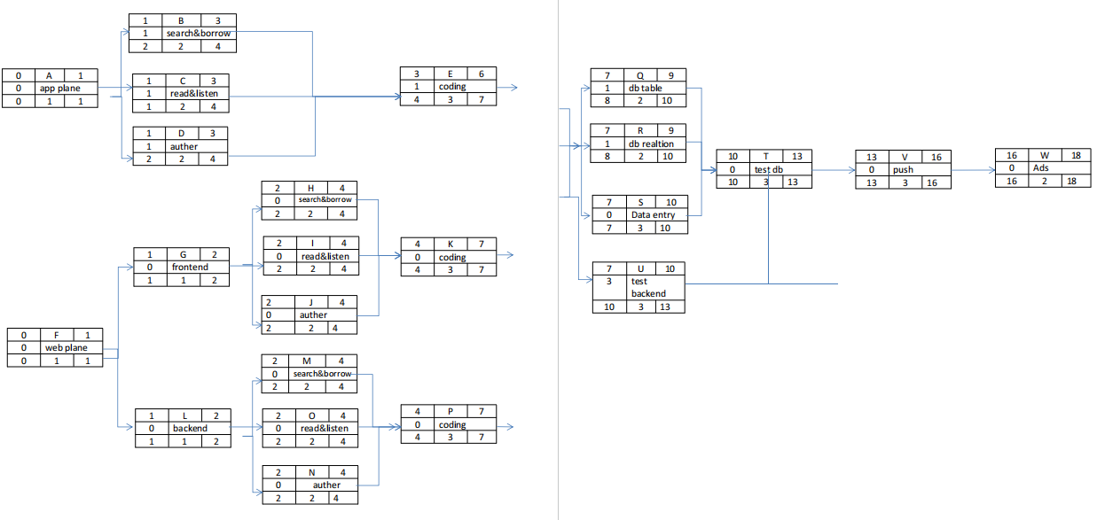

The Matrix Responsibilities
Task/job |  |  | Project Manager | Application developer | Frontend developer |  | Backend developer | Database administrator | Network  engineer | tester | Marketing team
architectural designs |  |  | A | P | P |  | P | R | C
Design App |  |  | A | C |  |  |  | P | P
Test App release |  |  | A |  |  |  |  | P | P | R
Test the App |  |  | A | C |  |  |  |  |  | C
Design Website |  |  | A |  | C |  | R | P | R
Test website release |  |  | P |  | R |  |  |  | P | C
Test the website |  |  | A |  | P |  | P |  |  | C
Create database |  |  | A |  |  |  |  | C | R
Push the App |  |  | R | P |  |  |  |  | P
Push the website |  |  | R |  | P |  | P |  | P
Make adds |  |  | A |  |  |  |  |  |  |  | C
 | P | Participate
 | A | Approve
 | C | Create
 | R | Responsible

- Resource

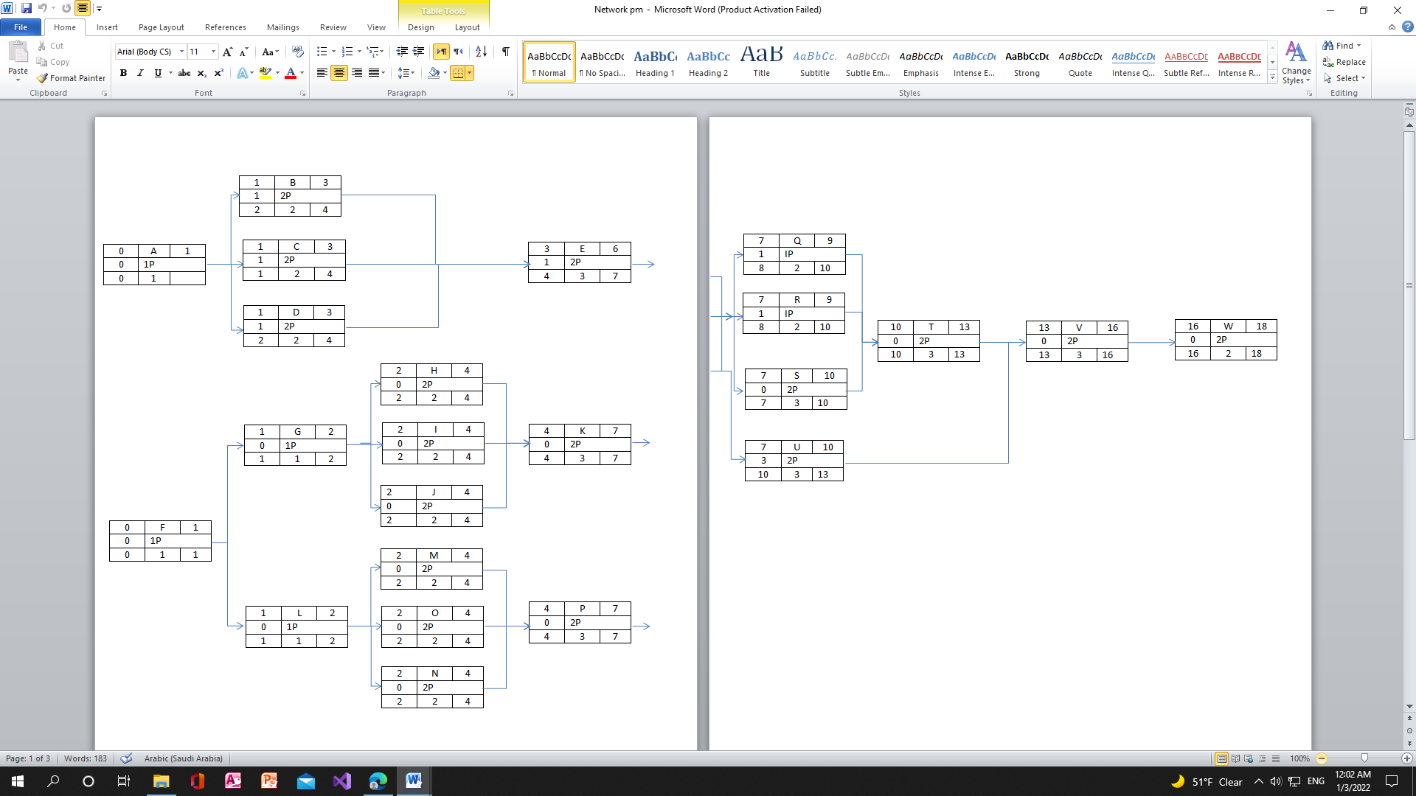

ID | RES | DUR | ES | LF | SL | 1 | 2 | 3 | 4 | 5 | 6 | 7 | 8 | 9 | 10 | 11 | 12 | 13 | 14 | 15 | 16 | 17 | 18 | 19
A | 1P | 1 | 0 | 1 | 0 | 1
B | 2P | 2 | 1 | 4 | 1 |  | 2 | 2
C | 2P | 2 | 1 | 4 | 1 |  | 2 | 2
D | 2P | 2 | 1 | 4 | 1 |  | 2 | 2
E | 2P | 3 | 3 | 7 | 1
F | 1P | 1 | 0 | 1 | 0 | 1
G | 1P | 1 | 1 | 2 | -2 |  | x | x | 1
H | 2P | 2 | 2 | 4 | -1 |  |  | x | 2 | 2
I | 2P | 2 | 2 | 4 | -1 |  |  | x | 2 | 2
J | 2P | 2 | 2 | 4 | -3 |  |  | x | x | x | 2 | 2
K | 2P | 3 | 4 | 7 | -2 |  |  |  |  | x | x | 2 | 2
L | 1P | 1 | 1 | 2 | -2 |  | x | x | 1
M | 2P | 2 | 2 | 4 | -2 |  |  | x | x | 2 | 2
N | 2P | 2 | 2 | 4 | -4 |  |  | x | x | x | x | 2 | 2
O | 2P | 2 | 2 | 4 | -4 |  |  | x | x | x | x | 2 | 2
P | 2P | 3 | 4 | 7 | -4 |  |  |  |  | x | x | x | x | 2 | 2 | 2
Q | 1P | 2 | 7 | 10 | -1 |  |  |  |  |  |  |  | X | 1 | 1
R | 1P | 2 | 7 | 10 | -1 |  |  |  |  |  |  |  | X | 1 | 1
S | 2P | 3 | 7 | 10 | -3 |  |  |  |  |  |  |  | X | x | X | 2 | 2 | 2
T | 2P | 3 | 10 | 13 | -3 |  |  |  |  |  |  |  |  |  |  | x | x | x | 2 | 2 | 2
U | 2P | 3 | 7 | 13 | -4 |  |  |  |  |  |  |  | x | x | x | x | 2 | 2 | 2
V | 2P | 3 | 13 | 16 | -1 |  |  |  |  |  |  |  |  |  |  |  |  |  | x | 2 | 2 | 2
W | 2P | 2 | 16 | 18 | -1 |  |  |  |  |  |  |  |  |  |  |  |  |  |  |  |  | x | 2 | 2
Total Resource Load |  |  |  |  |  | 2 | 6 | 6 | 6 | 4 | 4 | 8 | 6 | 4 | 4 | 4 | 4 | 4 | 4 | 4 | 4 | 2 | 2 | 2
Resource Available |  |  |  |  |  | 3P | 6P | 6P | 6P | 3P | 12P | 12P | 6P | 6P | 6P | 6P | 6P | 4P | 4P | 4P | 4P | 3P | 3P

- Budget
Matrix of Activity with cost

ID |  |  |  | ID
A | 8000 |  |  | M | 2000 | 2000
B | 500 | 500 | 500 | N | 2000 | 2000
C | 500 | 500 | 500 | O | 2000 | 2000
D | 500 | 500 | 500 | P | 2000 | 3000 | 3000
E | 1000 | 2000 | 2000 | Q | 1000 | 1000
F | 34000 |  |  | R | 1000 | 1000 | 1000
G | 14000 |  |  | S | 500 | 500
H | 1500 | 1500 | 1500 | T | 500 | 1000 | 500
I | 1500 | 1500 | 1500 | U | 1000 | 500 | 500
J | 1500 | 1500 | 1500 | V | 1000 | 1000 | 1000
K | 1000 | 2000 | 2000 | W | 1000 | 1000 | 1000
L | 12000

Baseline Budget

ID | Budget | 1 | 2 | 3 | 4 | 5 | 6 | 7 | 8 | 9 | 10 | 11 | 12 | 13 | 14 | 15 | 16 | 17
A | 8000
B | 1000 | 500 | 500
C | 1000 | 500 | 500
D | 1000 | 500 | 500
E | 5000 |  |  | 2000 | 1000 | 1000
F | 34000
G | 14000
H | 3000 |  | 1500 | 1500
I | 3000 |  | 1500 | 1500
J | 3000 |  | 1500 | 1500
K | 5000 |  |  |  | 2000 | 2000 | 1000
L | 20000
M | 4000 |  | 2000 | 2000
N | 4000 |  | 2000 | 2000
O | 4000 |  | 2000 | 2000
P | 8000 |  |  |  | 2000 | 3000 | 3000
Q | 2000 |  |  |  |  |  |  | 1000 | 1000
R | 3000 |  |  |  |  |  |  | 1500 | 1500
S | 1000 |  |  |  |  |  |  | 600 | 200 | 200
T | 2000 |  |  |  |  |  |  |  |  |  | 500 | 500 | 1000
U | 2000 |  |  |  |  |  |  | 500 | 1000 | 500
V | 3000 |  |  |  |  |  |  |  |  |  |  |  |  | 1000 | 1000 | 1000
W | 2000 |  |  |  |  |  |  |  |  |  |  |  |  |  |  |  | 1000 | 1000
Total | 57000 | 1500 | 12000 | 12500 | 5000 | 6000 | 4000 | 3600 | 3700 | 700 | 500 | 500 | 1000 | 1000 | 1000 | 1000 | 1000 | 1000
Commutative |  | 1500 | 13500 | 26000 | 31000 | 37000 | 41000 | 44600 | 48300 | 49000 | 49500 | 50000 | 51000 | 52000 | 53000 | 54000 | 5600 | 5700

